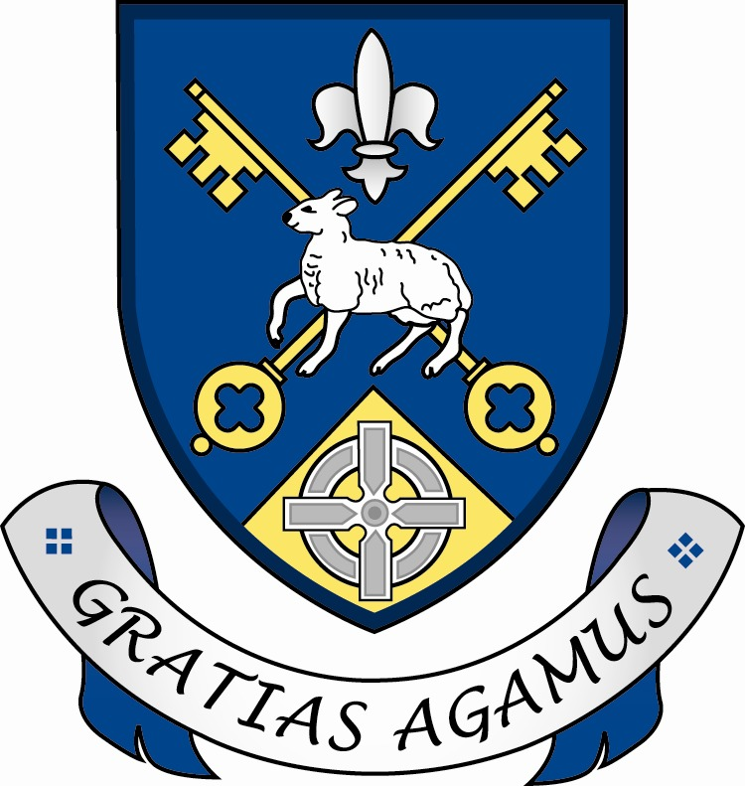

Our Lady and St Patrick’s College, Knock

H2/H4 Verification Certificate

This certificate should be completed and uploaded with the Transfer Application. It must be verified and signed by: a primary school Principal; or an elected public representative; or a medical practitioner; or a lawyer; or a member of the clergy who knows the applicant and family for at least two years and is not a member of the applicant’s family. There is no requirement that the verifier must be a resident in NI/GB. Failure to have the certificate duly completed will result in the child not meeting subsidiary criterion H2 and/or H4 of the published Admissions Criteria.
Child’s Details
Forename(s) |  | Permanent Address/Place of Residence
Surname |  | Permanent Address/Place of Residence
Date of Birth |  | Permanent Address/Place of Residence

H2 Verification (Please tick/complete as appropriate)
I confirm that: |  | Tick |  | Complete below for H2(ii) only.
(i) | this applicant is the eldest or only child of the family. |  |  | Name and date of birth of the sibling who is the eldest child
(ii) | this applicant has a sibling who is the eldest child. He/She achieved a grade A in the PPTC GL Assessment and applied to the College. The sibling’s application was provided to the College by the EA and was considered by the Board of Governors but he/she was not selected. |  |  | Year of his/her P7 application to the College
(iii) | every older sibling of this applicant did not achieve a grade A in the PPTC GL Assessment. |  |  | The sibling’s post-primary school

H4 Verification
I confirm that the address stated for this applicant is his/her permanent place of residence. |  | Yes / No (delete as appropriate)

Verification Signatory: I confirm that I have known this child and family for at least two years.
I certify to the best of my knowledge and belief that the information provided above is correct.
Name |  | Occupation
Contact Number |  | Professional Address/  Official Stamp
Signature |  | Date

The Admissions Committee of the Board of Governors may contact you to confirm this verification.

